The first of its kind
WTX HFDS from CERATIZIT: Innovative drill with four cutting edges

Date of publication: April 2020
Reference: PR-20-04-WTX HFDS

Many innovations, firsts or revolutions often turn out to be nothing more than facelifts or updates once you look under the bonnet. The same cannot be said for the WTX HFDS from CERATIZIT – without question the first and only four-edged high-feed drill on the market. Impressive cutting data and tool life in steel and cast iron materials clearly demonstrate the fourth cutting edge is not there just for show.
The superlatives that preceded the launch of the new drill have pushed expectations among potential users a notch higher: innovative, unprecedented results, a new benchmark in the drill segment. These are the criteria by which the world's first high-feed drill with four effective cutting edges, the WTX HFDS from CERATIZIT, will be judged.
A speed and endurance champion
"No matter what we put it up against, the WTX HFDS is faster every time! It reduces machining times by up to 66% in comparison with standard two-edged and three-edged high-speed and high-feed drills!" says a delighted Felix Meggle, Product Manager Drilling Tools at CERATIZIT. Designed and engineered as a specialist tool for steel and cast iron, the drill cuts through these materials like a knife through butter, "at high speed and with the ultimate in precision. If we replicated that performance on the road, we'd be getting a knock on the door from the police!" adds Meggle. And for those of you thinking that this just means you'll be changing the tyres sooner, think again: this four-edged marvel is not just as quick as lightning, it will run rings round any competitor in an endurance race too.
Mass and class
"The WTX HFDS is far more than just a speed and productivity merchant. It also delivers high quality in terms of positioning accuracy, tolerance and the roundness/cylindricity of the holes produced," explains Meggle. Field trials showed an average positioning accuracy of 0.03 mm for the entire hole depth; an astonishing result in light of the cutting data. "With a WTX HFDS Ø6.80 mm, 5xD we can cut into 1.7331 / 16MnCr5 at a cutting speed of Vc= 120 m/min and a feed per revolution of F= 0.50 mm/U to produce holes with an H7 tolerance," adds Meggle by way of example. All this is made possible by the special pyramid-shaped drill tip, which is completely unlike a conventional chisel edge and allows for exceptional centring of the drill. Four continuous spiral coolant holes ensure optimal cooling of every cutting edge, while the tool core still remains extremely stable. In addition, the WTX HFDS produces only a slight burr when entering and exiting the hole.
Legendary protection for epic performance
A global first like the WTX HFDS leaves nothing to chance, as demonstrated by the legendary Dragonskin DPX14S coating from CERATIZIT. The TiAlN nanolayer is resistant to application temperatures of 1000°C, clearing the last potential obstacle in the way of the new four-edged solid carbide drill delivering its epic levels of performance. "And the best thing is that the WTX HFDS will be available in stock in diameters from 6.00 to 16.00 mm by the time the CERATIZIT Up2Date catalogue is published in May 2020." Felix Meggle is already looking forward to introducing delighted users to this CERATIZIT innovation!
For more details as a well as a product video of the first four-edged high-feed drill – WTX HFDS – go to cuttingtools.ceratizit.com/de/de/wtx-hfds.

Attachments:
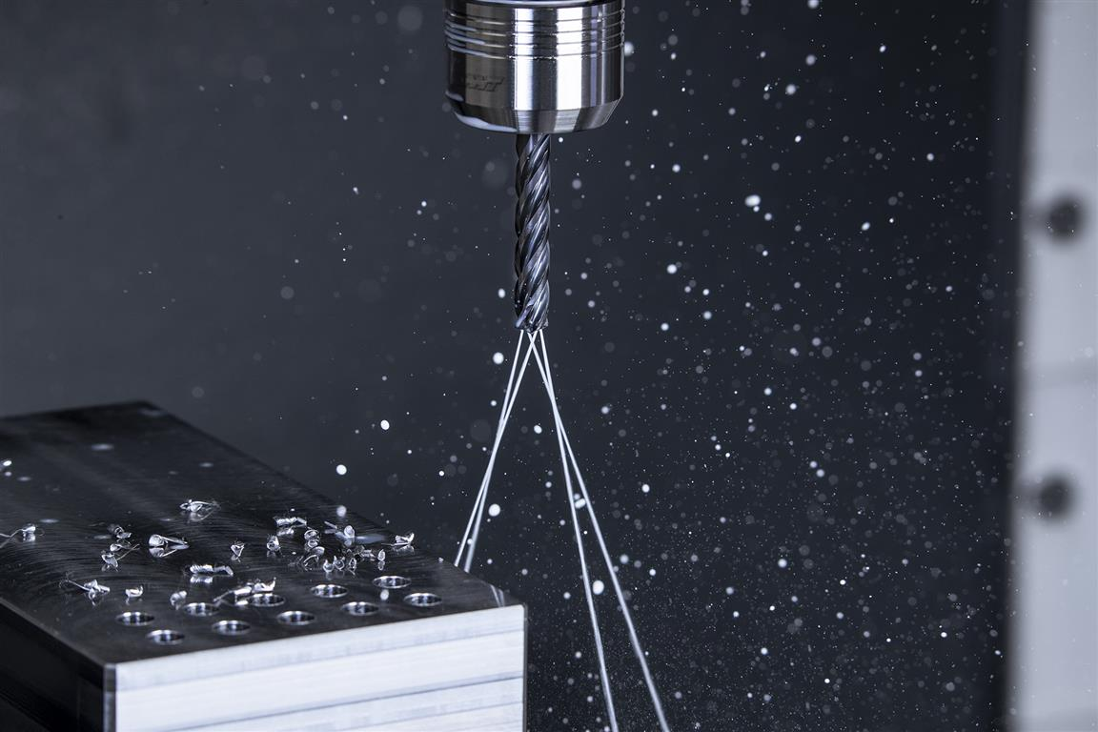
The new WTX HFDS four-edged high-feed drill works faster for longer and, in doing so, breaks all performance records.

Published on behalf of

CERATIZIT Deutschland GmbH
Marketing \ Communications
Daimlerstraße 70 \ 87437 Kempten \ Germany
T. +49 831 57010-3405
F. +49 831 57010-3649
E. Norbert.Stattler@ceratizit.com

www.ceratizit.com

CERATIZIT – With passion and a pioneering spirit for carbides
For more than 95 years, CERATIZIT has been a pioneer in the field of ambitious hard material solutions for machining and protection against wear. The private company, with registered offices in Mamer, Luxembourg, develops and produces highly specialised cutting tools, indexable inserts, rods made from hard materials and wearing parts. We are the global market leader in various application segments for wearing parts and are successfully developing new carbide, cermet and ceramic grades, for example in woodworking and stone working.
With more than 9,000 employees at 34 production facilities worldwide and a sales network with over 70 branches, the Group is a global player in the carbide sector. Our international network also includes subsidiaries KOMET, WNT, Becker Diamantwerkzeuge and Stadler Metalle, as well as the CB-CERATIZIT joint venture. As a technology leader, we continuously invest in research and development and hold over 1,000 patents. Our innovative carbide solutions are used in the mechanical engineering and tool making sectors, in the automotive industry, the aviation and aerospace industry, and in the medical industry.
We are represented on the market by our seven flagship brands, Hard Material Solutions by CERATIZIT, Toolmaker Solutions by CERATIZIT, Tool Solutions by CERATIZIT, Cutting Solutions by CERATIZIT, KOMET, WNT and KLENK.

www.ceratizit.com \ www.kometgroup.com \ www.wnt.com \ www.klenk-tools.de

