heimatec.icosen® enables the move into digital manufacturing with heimatec tooling units
Renchen/Hanover, 18/09/2023: With heimatec.icosen®, heimatec offers its customers the capability to make their manufacturing more and more digital. Using its variety of sensors, the status of tool units may monitored centrally. When should the next service date be planned for? How can the manufacturing process be further optimized? All these issues may be resolved more easily via the sensor unit.
icosen® is equipped with a number of sensors. Temperature, rotational speed and vibrations are measured. The sensor unit works with energy self-sufficiency on driven tool units. In real time, the sensor communicates the measurement data in a standardized protocol, which simplifies the integration into the infrastructure. Overall, machine operators’ work effort is reduced, which in turn brings time and cost advantages.

For example, the sensors could be useful to machine operators, shift managers or maintenance engineers. The machine operator is able to optimize his process, as he receives information on temperature and vibrations within the tool unit. The shift manager is able to monitor all tool units from a centralized position and gain insights from status reports, which facilitate decision-making on any interventions that are needed. The maintenance engineer can call up information on when the next service of the tool unit is required and thereby plan servicing dates better.

The newly-developed sensor unit for heimatec.icosen® tool units is currently still undergoing field tests.

heimatec has been specializing in the design, manufacture and distribution of high-precision static tool holders and driven tool units for lathes and machining centers for more than 35 years. The entire tool palette includes several thousand products. heimatec is one of the leading international precision tooling companies in terms of technology and quality. Headquartered in Renchen, Germany, heimatec has a subsidiary in India and numerous representatives and trading partners all over the world.
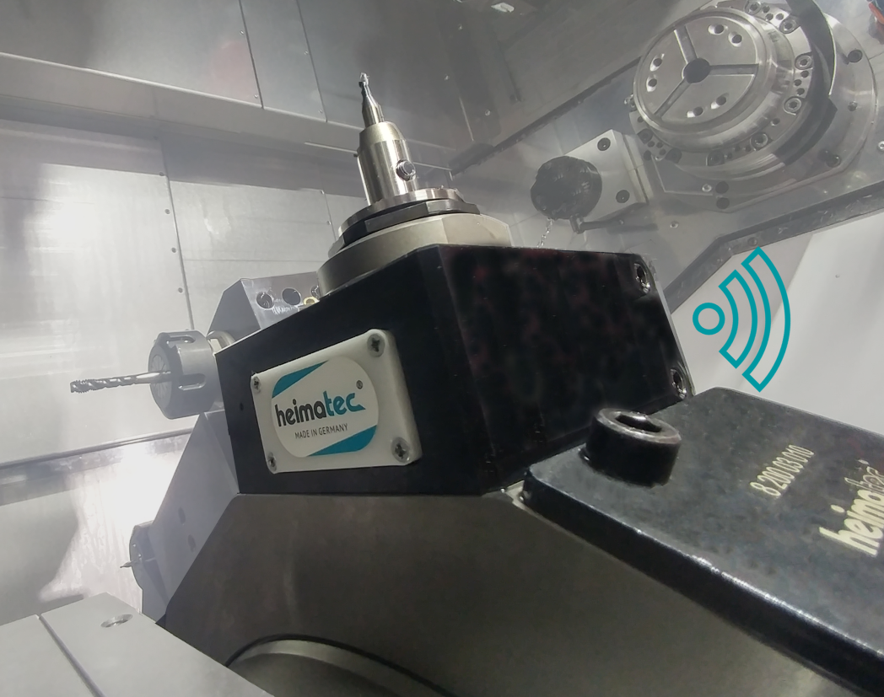
Picture: heimatec.icosen®
Caption: heimatec.icosen® enables the move into digital manufacture
Image source: heimatec GmbH

Contact
heimatec GmbH
Carl-Benz-Str.4
DE-77871 Renchen

Contact persons
Iris Dilzer (Marketing)
Dirk Hund (Sales)

Phone.: +49 (0)7843 9466 0
Fax: +49 (0)7843 9466 66
marketing@heimatec.de
www.heimatec.de

In the case of publication, we ask for a copy.

